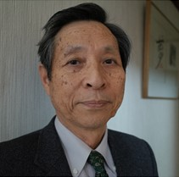 | SHIGERU KUMAZAWA, PhD

Shigeru Kumazawa, after retiring as a principal scientist at the former Japan Atomic Energy Research Institute, he was a senior expert at the former Japan Nuclear Energy Safety Organization, a technical advisor of the Secretariat of the former Cabinet Office Nuclear Safety Committee. He served as a USEPA (radiation) expert in 1981-1984 and served as a scientific advisor of the delegation of Japan to the UNSCEAR in 1988-1997. He holds a PhD in Nihon University's Faculty of Engineering Science. Application of pattern recognition to neutron dosimetry, discrete spherical harmonics expansion method for 4π dependent organ dose, hybrid lognormal distribution model of worker dose managed by dose limit and ALARA, and extended hybrid scale models for both dose and risk assessment. He is currently focusing on the characteristics of quantities that are effectively adjusted to avoid excessive amounts applied to both radiation effect and protection.

