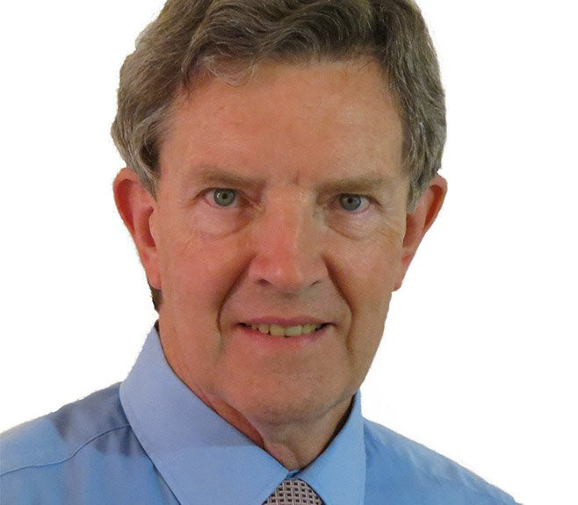
KELVIN KEMM
Nuclear Physicist, South Africa

Kelvin Kemm holds a Ph.D. in nuclear physics. He is Chairman of South Africa Nuclear Energy Corporation, NECSA, CEO of Nuclear Africa (Pty) Ltd, member of the Board of Advisors for the Committee for A Constructive Tomorrow, CFACT, in Washington, D.C., and member of the Board of Advisors for Environmentalists for Nuclear – USA in Denver, Colorado. He is a central figure in the development of additional nuclear power in South Africa and the future use of nuclear energy and nuclear science across Africa. Author of numerous articles and publications about nuclear energy and the science and politics of man-made climate change.

