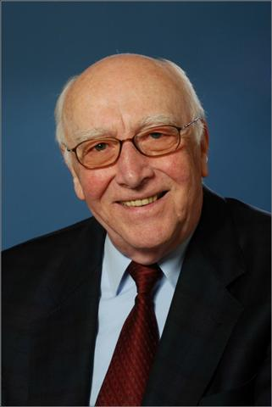

Ludwig E. Feinendegen, MD

Ludwig Feinendegen, MD (Cologne University, Germany, 1952), is Full Professor Emeritus in Nuclear Medicine at the Heinrich Heine University Dusseldorf, Germany. He is associated with the Brookhaven National Laboratory (BNL since 1958, joined EURATOM in Brussels 1963, and the Curie Institut du Radium, Paris, 1964-1967. He directed the Department of Nuclear Medicine, University Dusseldorf, and Medical Institute at the Research Center Julich 1967- 1993; then was program manager at the Office of Biological and Environmental Research in the DOE 1994-1998, and Fogarty Scholar at the NIH 1998-1999. He was member of if the German Commission on Radiation Protection 1971-1987. NCRP-Com-2 1969-1979, IICRP Com.2 1973-1985, and ICRU 1982-2006. In 1977 – 1978 he was president of the European Society for Radiation Biology.

Major research contributions and discoveries include: First description of RNA synthesis at the chromatin of the mammalian cell nucleus with subsequent move of the RNA into the nucleolus and cytoplasm; no RNA synthesis during mitosis. – Development of multi-parameter and -tracer technics for quantification of biochemical reactions at defined body sites by functional imaging.– First suggestion and description of the Auger effect as tool in bio-medicine. - First description of delayed onset and temporary biochemical responses to very low dose and low-LET radiation, with ensuing adaptive responses/protection and radiation-hormesis. - Introduction of the cell-dose concept for linking tissue risks to low-dose and low dose-rate irradiation.

Feinendegen is author/coauthor of more than 370 peer-reviewed publications, book-chapters, monograph and textbook. He received numerous awards and prizes.

