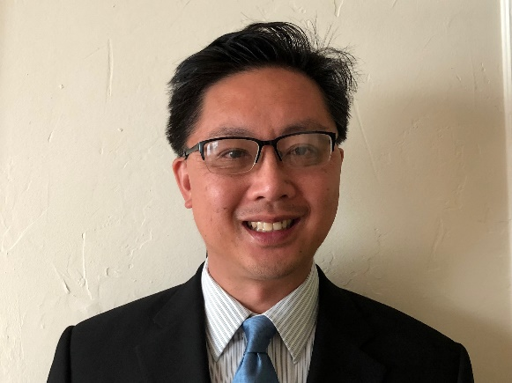

Allen T. Chan

Allen T. Chan is a senior analyst for the U.S. Government Accountability Office (GAO). He has worked at GAO for 15 years and is on GAO’s Natural Resources and Environment team. Last year, he and his colleagues published a report titled, “Low-Dose Radiation: Interagency Collaboration on Planning Research Could Improve Information on Health Effects.” Prior to working at GAO, he worked as a senior production planner at a nuclear magnetic resonance instruments manufacturer and a project manager at a food packaging and processing equipment manufacturer. He holds a Masters of Public Policy degree from the University of California at Berkeley.

