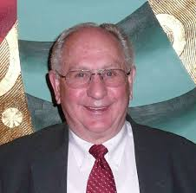

Dr. Antone Brooks

Dr. Brooks earned his Associate degree at DIXIE JC in St. George Utah, B.S. in Experimental Biology and M.S. in Radiation Ecology at the University of Utah. He received his Ph.D. in Physical Biology at Cornell University.

Dr. Antone L. Brooks is retired as a Professor from the Environmental Science Department at Washington State University Tri-cities. He was a Senior Scientist at PNNL, Manager of the Cellular and Molecular Toxicology Group at Lovelace ITRI, Albuquerque, New Mexico, and worked in Washington D.C. for the U.S. Department of Energy, Office of Health and Environmental Research as a Technical Representative. Dr. Brooks served as the “Chief Scientist for the DOE Low Dose Research Program". He has recently written a book, “Low Dose Radiation, The History of the U.S. Department of Energy Research Program.”

Professor Brook’s specific research interests include cytogenetics, radiation induced cancer, radiation risk, and public outreach on radiation effects. The focus of his research has been understanding the biological changes induced by low doses of ionizing radiation with special emphasis on internally deposited radioactive material. This research has resulted in more than 200 open literature publications.

